Evidence for the COPY/PASTE function NOK on ZOS MF.
Issue :- When we are trying to copy and paste data from ZOS MF to add comments/notes in INCIDENTS or Chat Channels, the orientation and indentation is not proper and the format is not readable
EX:- Let’s say we login to ZTV inside ZOS MF we have to Copy and paste the below circled data in red and paste in INCIDENT/Chat Channel for further investigation
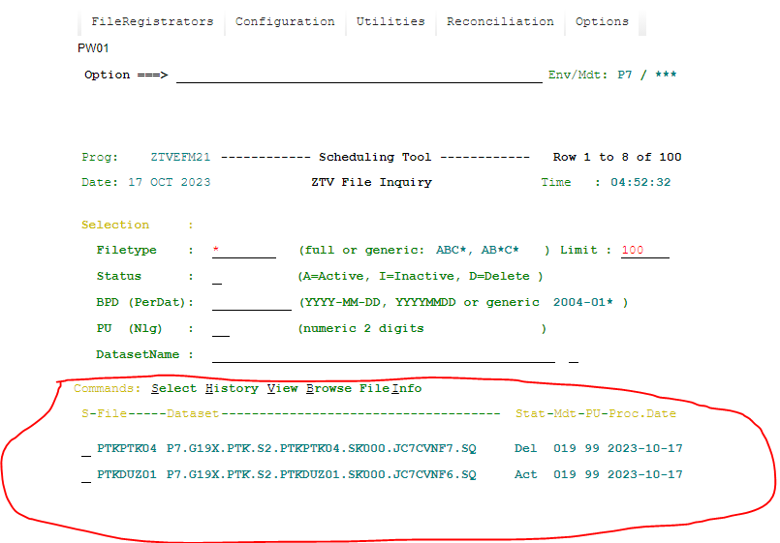So when we copy and paste the above data below is the output , Which is clearly not readable, because of the indentation.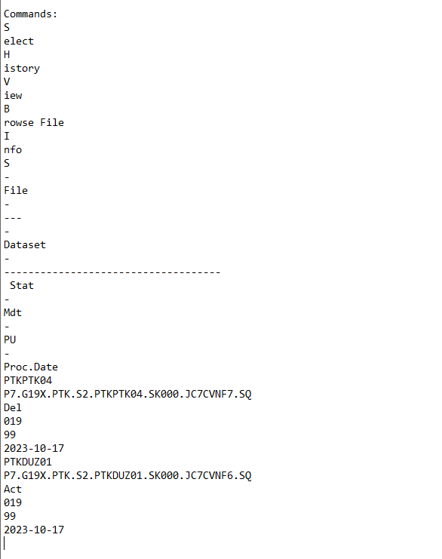
Business Justification:-

- What do we want to achieve with this feature?
When we forward an Incident/ticket to second level support or any other team for further analysis or as a proof, we put our findings i.e. Copy the required details and paste it in the ticket, so that second level support does not have to investigate from the scratch.
So what we want to achieve is when we Copy and Paste the output it should be in readable format , similar to screenshot shown in below Point no 3.

- What do we lose/Impact when we do not have this feature?
We would have to manually copy and paste line by line or word by word the required details. Because we cannot forward the ticket without pasting the findings in it, and copy and pasting manually is really a tedious task and sometimes won’t even be possible because the whole indentation is not correct as each and every word is pasted on new line as shown in 2nd Screenshot output on the last page.

- How are we currently achieving this ?
Currently using TSO via reflection, we when we copy paste the output of the same data defined in 1st screenshot below is the output which is clearly readable and also as per indentation.

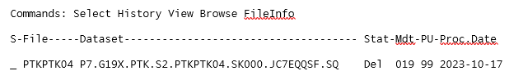

- Do we have a workaround?
No Workaround, alternative would only be to copy paste things manually into a incident which is tedious task that too sometimes copy/Paste line by line or maybe letter by letter.

Note :-
Also in future if any other tool is integrated with ZOS MF and if we have the same situation performing copy and paste it would be really difficult to perform copy/paste from ZOS MF.

